Mrs. Soto - Art 1

Unit: Drawing  Lesson: Line  Dates: August 28, 2017-September 7, 2017  3 class period | Grades  Practice: Zentangle Practice with 3 Animal Thumbnails  Assessment: Zentangle Rubric

Objective:  Students will study, practice, and create artwork using the Element of Art, Line. Students will draw contour lines and use the Zentangle technique to illustrate an animal.  Size: 9” x 12”  Materials: Paper, Pencil, Sharpie, Ink | TEKS:  A. Knowledge & Skills  b. identify and understand the elements of art, including line  B. Creative Expression  d. create original artwork to communicate thoughts,  feelings, ideas, or impressions;
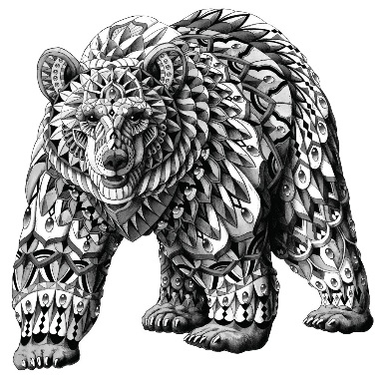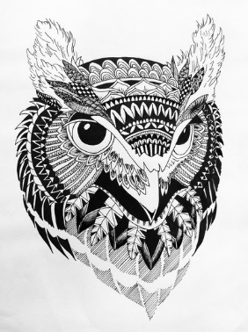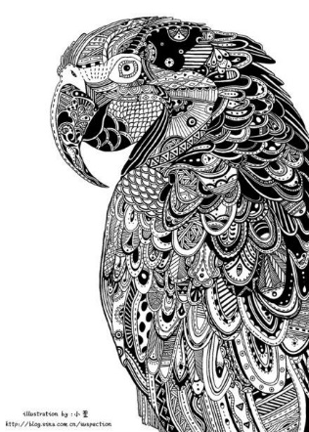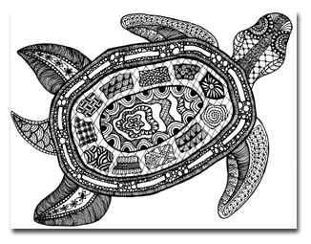

Zentangle Rubric | 25 | 20 | 15 | 10
Creativity/ Animal | -Contour drawing will cover 80% of the paper.  -Interesting angle of animal.  -Looks dimensional. | -Animal drawing is 60% of paper.  -Straight forward image of animal.  -Some dimension | -Animal drawing is 50% of the paper.  -Noncomplex image of animal.  -Very little dimension | -Animal drawing is 40% or less of the paper.  -Image is simple  -Little to no dimension/ flat image.
Contour Line | -Animal has proportionate outside and inside contour lines.  -No missing lines.  -Showing mastery of Line- An Element of Art | -Animal contour lines have a 75% accuracy on the outside and inside. -Few missing lines.  -Demonstrates understanding of Line. | -Animal contour lines have a 50% accuracy on the outside and inside. -Many missing lines.  -Attempted to create Line in some areas. | -Animal contour lines have 25% accuracy on the outside and inside. -Numerous missing lines.  -Little understanding of Line.
Zentangles | -All contour lines are finished with marker.  -At least 10 different, creative, unique zentangle patterns.  -No blank space is greater than ½ inch. | -Most contour lines are finished with marker.  -At least 8 different, creative zentangle patterns.  -Very little blank spaces greater than ½ inch. | -Some contour lines are finished with marker.  -At least 6 different zenangle patterns.  -Many blank areas larger than 1/2inch. | -Few contour lines are finished with marker.  -Only used 4 or less zentangle patterns.  -Numerous blank areas larger than 1/2inch.
Craftsmanship | -Pencil lines are completely erased.  -No smudges  -No marker bleeding  -No tears/rips/holes in paper | -Pencil lines are mostly erased.  -Very Few smudges  -Little marker bleeding  -No tears/rips/holes in paper | -Pencil lines are somewhat to be erased  -Some smudges  -Some marker bleeding  -One tear/rip/hole in paper | -Pencil lines are not erased on most of the drawing  -Many smudges  -Marker bleeding  -A couple tears/ rips/holes in paper

Comments: _____________%

