Hendrickson High School Art 1 Requirements
2016-2017
- Sketchbook
- 12” Ruler
- #2 Pencils (12)
- Eraser (Magic Rub)
- Optional: Ebony Pencils (2)
Handheld Pencil Sharpener
Color Pencils

Suggested- Spiral Bound (any side) Not suggested- Glue Bound (they fall apart)
9” x 12” or 8 ½” x 11”
Blank paper, 70+ pages
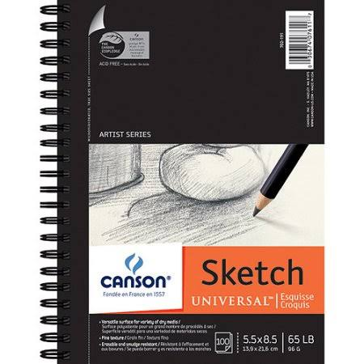

Places to buy a sketchbook: ($4-$25)
Hobby Lobby
Jerry’s Artarama
Michaels Art Store
Walmart
Target
Office Depot
Barnes & Noble
Walgreens/ CVS
Half Priced Books
Etc….

Supplies are needed by:___________________________________________

