Mrs. Soto – White Paper Sculpture

Unit: Principals of Art  Lesson: White Paper Sculpture  Vocab: Movement, Positive & Negative Space, Form  Dates: September 5, 2017-September 7, 2017  2 class periods | Grades  Practice: Sculpture Sketches (2)  Assessment: Paper Sculpture Rubric  Artist: Richard Sweeney -www.richardsweeney.co.uk  Jeff Nishinaka, www.jeffnishinaka.com

Objective:  Students will study the Principle of Art, Movement. Students will study Richard Sweeney and will create an original paper sculpture demonstrating movement. It will focus on the relationship between positive and negative space.  Materials: Computer paper, White paper | TEKS:  A. Knowledge & Skills  b. identify and understand the Principle of art, including Movement  B. Creative Expression  d. create original artwork to communicate thoughts,  feelings, ideas, or impressions;
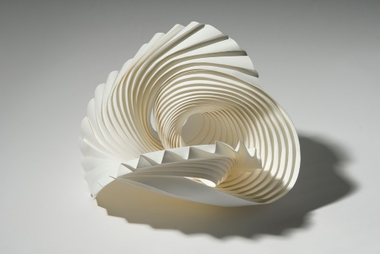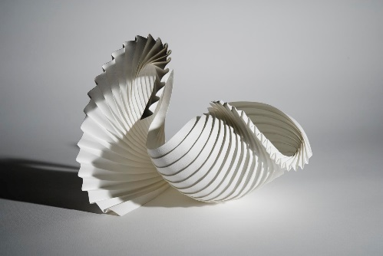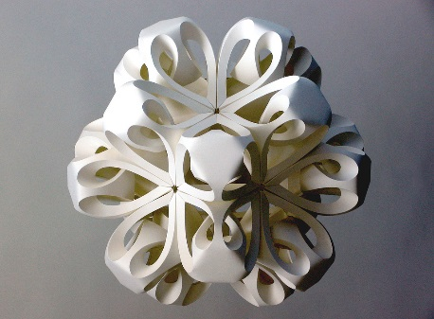

Paper Rubric | 25 | 20 | 15 | 10
Creativity | -Multiple components are used to create a complex and unique sculpture  -Challenging  -Original | -Some different components are used to create the sculpture  -Difficult  -Original | -Some different components are used to create the sculpture  -Interesting  -Original | -Few different components are used.  -Static  -Not original
Movement | -The eye moves throughout the sculpture and never stops.  -Lines and/or texture have been successfully skilled to make the eye move throughout  -Eye moves at bottom of sculpture, not heavy on table | -Eye moves throughout the piece, but runs off the edge or stops at a focal point  -Mostly consistent eye movement throughout the sculpture  -Sculpture has some movement on the bottom | -Eye starts to move, but goes off the sculpture or stops at the focal point  -Lines/ forms/ texture are present, but do not help move the eye.  Sculpture is mostly sitting on the table | -Sculpture is static  -Eye does not move throughout the sculpture  -Lines/Forms/textures are not used to move the eye.
Positive &  Negative Space | -The relationship between positive and negative space is extremely effective.  -The shapes of both are harmoniously allowing sculpture to be successful | -Either the positive space or negative is stronger  -Both positive & negative space are present, but not working together cohesively. | -Mostly has positive space or negative, but no relationship between the two.  -The positive and negative space are not the focus. | -Sculpture is majority of only positive or only negative space.  -No relationship between the positive and negative space.  -No interaction
In-The-Round | -Form- height/width/depth  -Has details on all sides  -Asymmetrical/ Not predictable, Strong | Form- height/width/depth  -Has details on most sides  - Not predictable  -Stands up independently | -Some form, but flat  -Does not stand up on its own very well  -Predictable | -Flat  -Does not stand up or easily falls down  -Very Predictable

Comments: _____________%

