Mrs. Soto – Panty Hose Sculpture

Unit: Principals of Art  Lesson: Panty Hose Sculpture  Vocab: Form, Balance, Emphasis, Wire, Planes,  Dates: September 20- 29th, 2017 | Grades  Practice: Sculpture Sketches (2)  Assessment: 1. Form and Balance Sculpture  2. Painting Artist influence with Emphasis  Artists: Form: Henry Moore, Barbara Hepworth  Painting: Van Gogh, Franz Marc

Objective:  Students will create understanding of the Element of Art FORM. Students will study Henry Moore and Barbara Hepworth for Form and will study multiple painters including Van Gogh and Franz Marc for painting ideas. Sculpture must have an Emphasis.  Materials: Wire, Wood, hot glue, panty hose, acrylic paint | TEKS:  A. Knowledge & Skills  b. identify and understand the Element of art, including Form  B. Creative Expression  d. create original artwork to communicate thoughts,  feelings, ideas, or impressions;

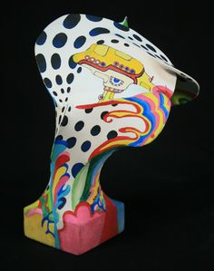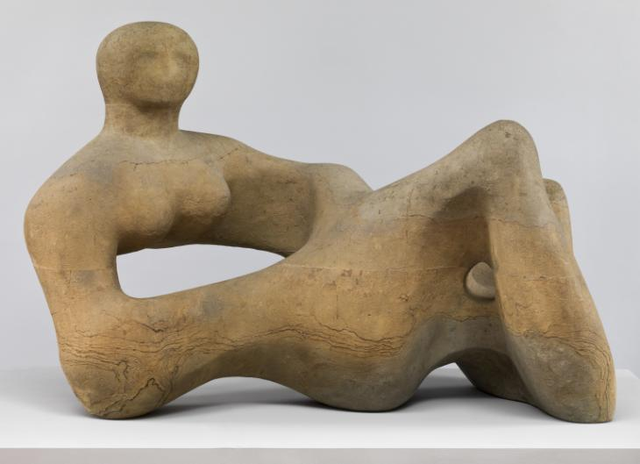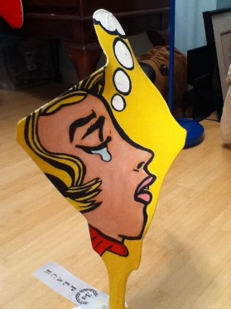
Panty Hose Form Rubric
 | 30 | 20 | 10 | 0
Balance | -Sculpture stands strong  -Interesting, dynamic  -Asymmetrical | -Sculpture wobbles a little, but is able to strongly stands  -Interesting  -Mostly Asymmetrical | -Fall over when touched lightly  -predictable  -Symmetrical | -Doesn’t stand  -Strait  -Not built correctly
Dimensional | -Numerous planes  -In- the –Round, all sides are complex, intricate  - No sides are entirely flat  - The width is expansive to give a lot of surface to paint | - Multiple planes  - In the Round  - Minimal areas of flat surface  -Sculpture is not wide and didn’t stretch panty hose enough, not as much surface area as possible to paint | -A couple of planes  -In-the round  -Multiple areas of flat surfaces  -Sculpture is narrow giving limited areas to paint | -Few to no planes  -Very flat, not In-the Round  -Sculpture is narrow and flat and won’t give a good surface to paint.
Movement | -Continuous and moves around the entire form | - Some aspects make the eye travel through most of the form | - Only two or less sides of the form make the eye travel | -The eye does not travel through the artwork
Construction | -Wood was sanded  -Wire was glued in each hole and is strong  -Sculpture is not moving and very sturdy  -No holes are present in the pantyhose | -Wood was mostly sanded  -Wire was attempted to be glued into wood  -Sculpture has little physical movement  -Tiny holes are present in pantyhose | -Wood was not sanded well  -Wire was not glued properly into wooden base  - | -Flat  -Does not stand up or easily falls down  -Very Predictable

Comments: _____________%

