Mrs. Soto – Drawing 1

Unit: Elements of Art  Lesson: Line  Dates: August 30, 2017-September 7, 2017  3 class periods | Grades  Practice: 2 Thumbnails  Assessment: Notebook Optical Illusion Rubric

Objective:  Students will study, practice, and create artwork using the Element of Art, Line. Students will demonstrate line while creating an original optical illusion on “notebook paper”.  Size: 9” x 12”  Materials: Paper, Pencil, Ink | TEKS:  A. Knowledge & Skills  b. identify and understand the elements of art, including line  B. Creative Expression  d. create original artwork to communicate thoughts,  feelings, ideas, or impressions;
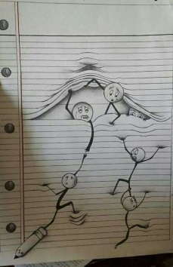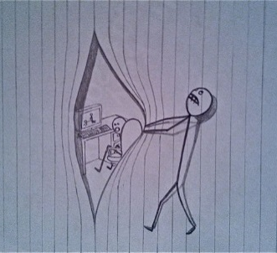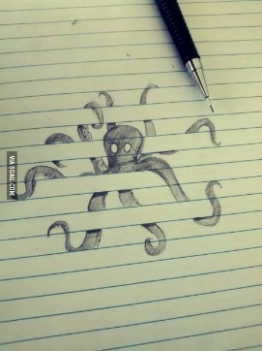

Notebook Optical Illusion Rubric

 | 25 | 20 | 15 | 10
Creativity | -Character(s) are original.  -Interesting angles of image(s)  -Tells a story with movement  -Images are in front and back of notebook lines | -Character(s) are original.  -Images are drawn straight forward  -Tells a story  -Images are mostly in front or behind notebook lines. | -Character(s) are original.  -Images are not drawn interestingly. Flat  -Story is not understood  -Images only go behind or in front of notebook lines. | -Character(s) are not original. They are copies.  -Images are flat and not interesting  -No story  -Images do not go behind or in front of notebook lines.
Line Craftsmanship | -No smudges, no messy pencil lines  -No tears/rips/holes in paper  -Uses a variety of lines  -Showing mastery of Line- An Element of Art | -Pencil lines are mostly erased.  -Very Few smudges  -No ears/rips/holes in paper  -Shows some variety of lines | -Pencil lines are somewhat to be erased  -Some smudges  -One tear/rip/hole in paper  -Shows little variety of lines | -Pencil lines are not erased on most of the drawing  -Many smudges  -A couple tears/ rips/holes in paper  -No variety of lines
Notebook paper | -Background has blue horizontal lines  -Side has red line and/or circle “holes”  -Looks exactly like notebook paper  -Lines are evenly spaces | -Background lines are present  -Side has red line and/or circle “holes”, but are not realistic  -A couple lines are not evenly spaced/ parallel | -Some background lines are present  -Attempted side with red line and/or “holes, but not finished  -Half of the lines are not evenly spaced | -Few background lines are present  -No attempt at red line or “holes”  -Lines are not evenly spaced and do not look like notepaper
Value and/or Color | -Images looks dimensional  -Artwork has great depth | -Most of the image(s) look dimensional  -Some depth to artwork | -Some of the image(s) look dimensional  -Little depth in artwork | -Little to no value or color on images.  -Little to no depth in artwork

Comments:
_____________%

