How to grid- Art 1/ HHS
1. Draw the 8inch x 10inch grid border
on the paper.
8in

10in

Paper=
9in x 12in

Border 1/2in

Border 1in

2. Draw the 2inch x 2inch grid LIGHTLY inside
the 8in x 10in border.
8in

10in

#3 Grid the picture 1inch by 1inch. Label.
A B C D
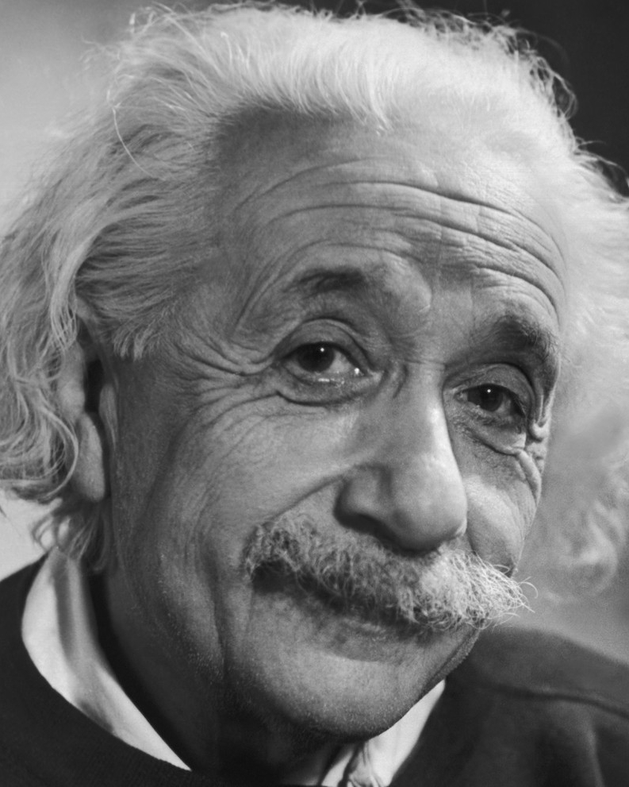
1

2

3

4

5
#4 Draw the contour lines
#5 Erase grid line before you add value!
Add value.
#6 Follow checklist on rubric.

How to grid- Art 1/ HHS
1. Draw the 8inch x 10inch grid border
on the paper.
8in

10in
Paper=
9in x 12in

Border 1/2in

Border 1in

2. Draw the 2inch x 2inch grid LIGHTLY inside
the 8in x 10in border.
8in

10in

#3 Grid the picture 1inch by 1inch. Label.
A B C D
1

2

3

4

5
#4 Draw the contour lines
#5 Erase grid line before you add value!
Add value.
#6 Follow checklist on rubric.

