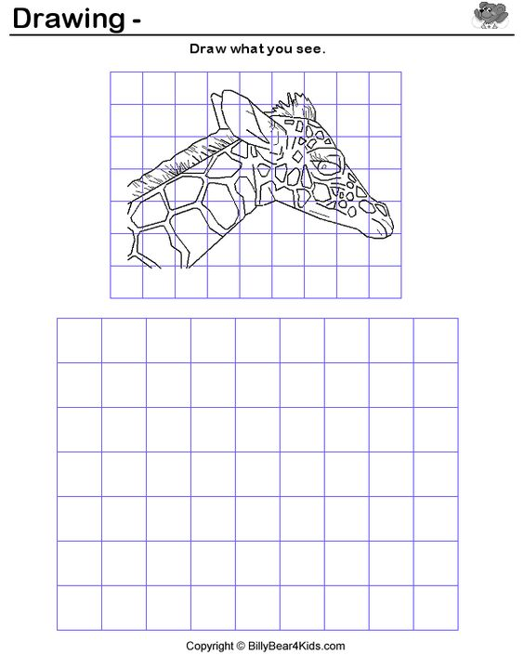

Use grid method to enlarge giraffe.