Name____________________________Period_______
Elements of Art
Match each Element with its visual definition.
________1. Line A.
________2. Shape B.
________3. Texture C.
________4. Value D.
________5. Color E.
________6. Space F.
________7. Form G.
Match the Artist with the Element:
Wassily Kandinsky Shape
Salvadore Dali Texture
Pablo Picasso Color
Alexander Calder Form
Vincent Van Gogh Value
MC Escher Space
Jackson Pollock Line

Label all the Elements of Art in this painting
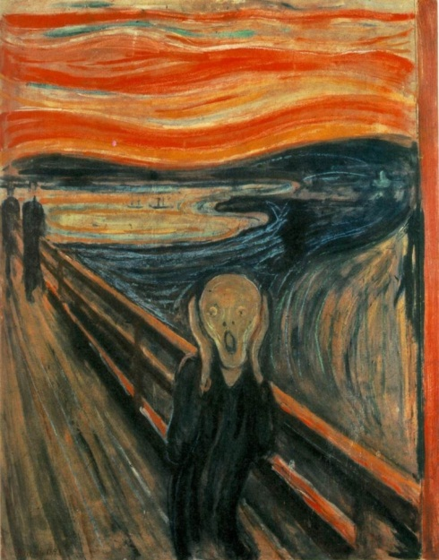
Name____________________________Period_______
Elements of Art
Match each Element with its visual definition.
________1. Line A.
________2. Shape B.
________3. Texture C.
________4. Value D.
________5. Color E.
________6. Space F.
________7. Form G.
Match the Artist with the Element:
Wassily Kandinsky Shape
Salvadore Dali Texture
Pablo Picasso Color
Alexander Calder Form
Vincent Van Gogh Value
MC Escher Space
Jackson Pollock Line

Label all the Elements of Art in this painting

Name____________________________Period_______
Elements of Art
Match each Element with its visual definition.
________1. Line A.
________2. Shape B.
________3. Texture C.
________4. Value D.
________5. Color E.
________6. Space F.
________7. Form G.
Match the Artist with the Element:
Wassily Kandinsky Space
Salvadore Dali Line
Pablo Picasso Form
Alexander Calder Texture
Vincent Van Gogh Shape
MC Escher Value
Jackson Pollock Color

Label all the Elements of Art in this Lichtenstein painting

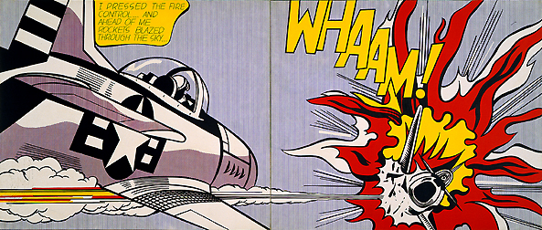

Name____________________________Period_______
Elements of Art
Match each Element with its visual definition.
________1. Line A.
________2. Shape B.
________3. Texture C.
________4. Value D.
________5. Color E.
________6. Space F.
________7. Form G.
Match the Artist with the Element:
Wassily Kandinsky Space
Salvadore Dali Line
Pablo Picasso Form
Alexander Calder Texture
Vincent Van Gogh Shape
MC Escher Value
Jackson Pollock Color

Label all the Elements of Art in this Lichtenstein painting

