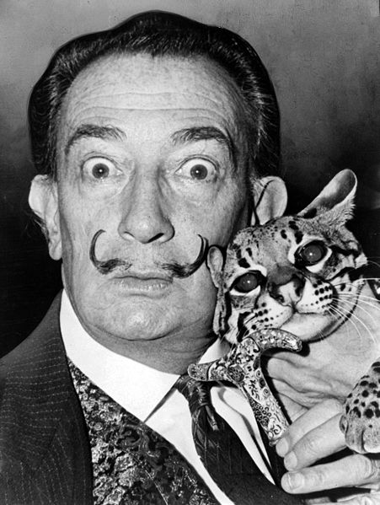
Creative Self Portrait Silhouette Painting
Art 1
Surrealist Artist: Salvador Dali
Grades: Minor- 1.) Worksheet 2.)Composition
Major- 1.) Sketchbook check, 2.) Final Painting
1. Complete the “Silhouette Self Portrait Visual Symbol Bank” Worksheet.
2. Trace the silhouette self-portrait on 9” x 12” paper from the projector in class.
3. Draw 10 images (5 per page for a total of 2 pages) from the worksheet in your sketchbook. Each image must be around 3”. Draw only contour lines. Look up the images and only draw the contour lines.
4. Draw the 10 images into your self-portrait (don’t draw in the background).
Tips: You can trace the images from your sketchbook on your final painting
Overlap images.
Think about hierarchy. Make the most important thing(s) to you the biggest in your drawing.
Draw images going off the page with image. Think about how to interestingly crop the images.
Fill the space.
Front, Middle, Background (foreground, middle ground, background)
5. Paint 100% of the portrait. Mix colors, be clean, intentional, and think about contrasting colors to create emphasis.

THIS IS ALL ABOUT YOU!
