Clay Monsters!
Days of construction- 4
April 4, April 6, April 12,
DUE- April 14, 2016
Days of construction- 4
April 4
April 6
April 12
DUE April 14, 2016-
Assessment grade

Art 1 Requirements:
- Size- 4inches
- Minimum of 8 additions
- Pinch pot(s) or Slab mug construction (with handle)
- Texture
- In-the-Round details
- Follow clay rules (CCT, Score/slip, No trapped air etc…)
- MUST BE ORIGINAL (nothing trademarked)
Questions:
Teacher tips:
- Asymmetrical design is more interesting!
- Be super creative!
- Keep clay close to the body or it will break off.
- Have fun and make something you are proud of!
What inspired your monster?
Does it have a function?
Does it have a story?
Does it have a superpower?
Animalistic? Humanistic? Alienistic? Foodistic? Etc…

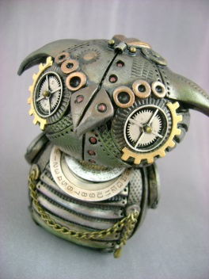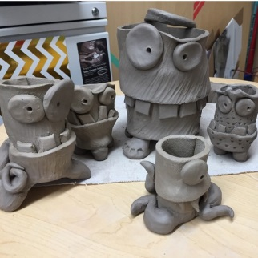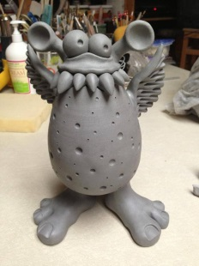
Do not copy these, just trying to give you a little inspiration.
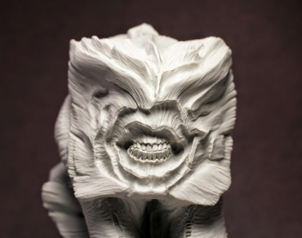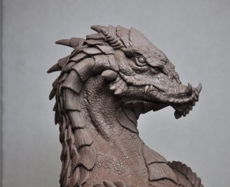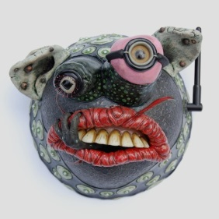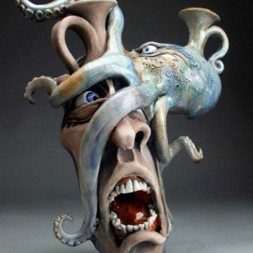
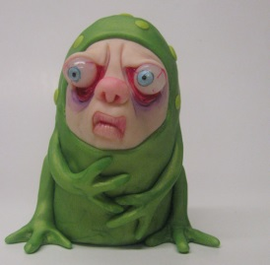
Definition of MONSTER
: a strange or horrible imaginary creature
: something that is extremely unusual
: a powerful person or thing that cannot be controlled and that causes many problems

