2nd Semester Art 1
Page 1- Full page. Draw your name in 1 point perspective.

Page 2- Full page. Draw three boxes in 2 point perspective. (One box above the horizon line, one on the line and one below the horizon line). Both vanishing points must be on the horizon line.
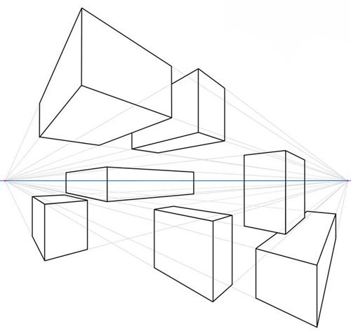

Page 3- (Full Page) Draw the corner of the room in 2 point perspective. The corner must be going away from you on this one. Must include door, window, furniture, ceiling, flooring and details.
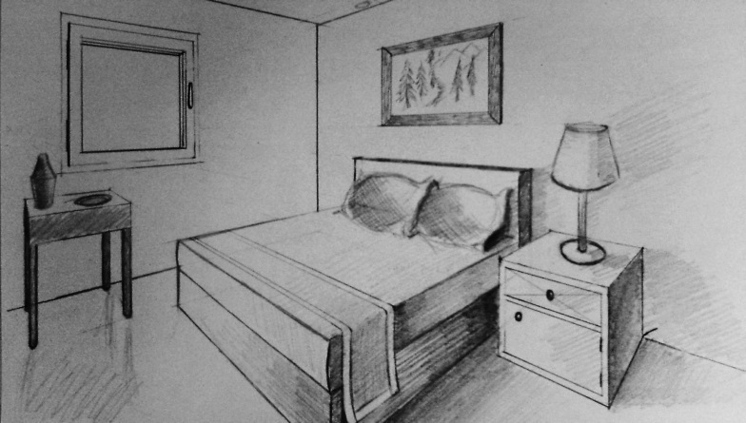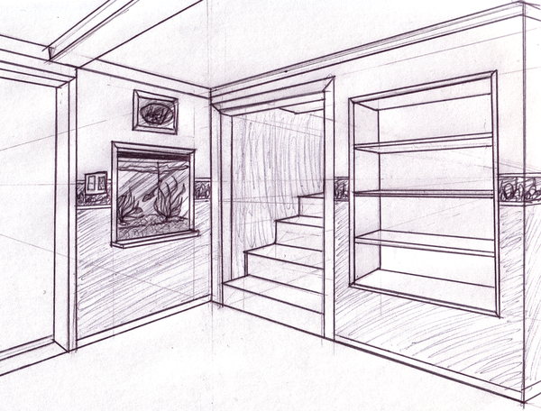
Page 4- (Full page) Draw the corner of the room in 2 point perspective. The corner must be coming toward you on this one. Must include door, window, furniture, ceiling, flooring and details.
